**Advance Excel Assignment 7**

1. **Using Insert Function, give examples of any function available in the different dropdowns present in the function library. For example, AutoSum, Recently Used, Text, Date & Time, etc.**

**Sum function:**

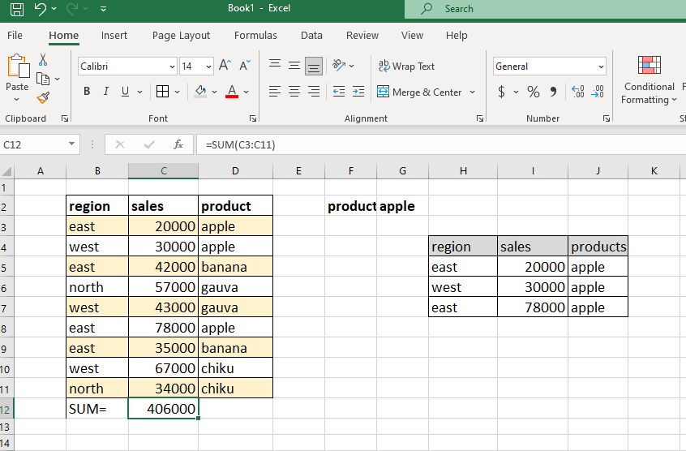

**Countif function:**

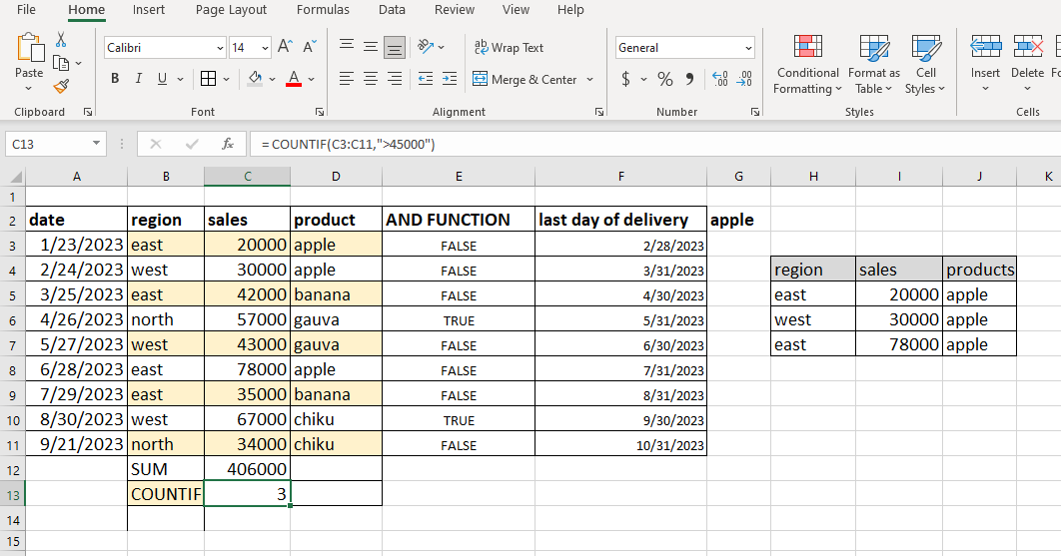

**And function:**

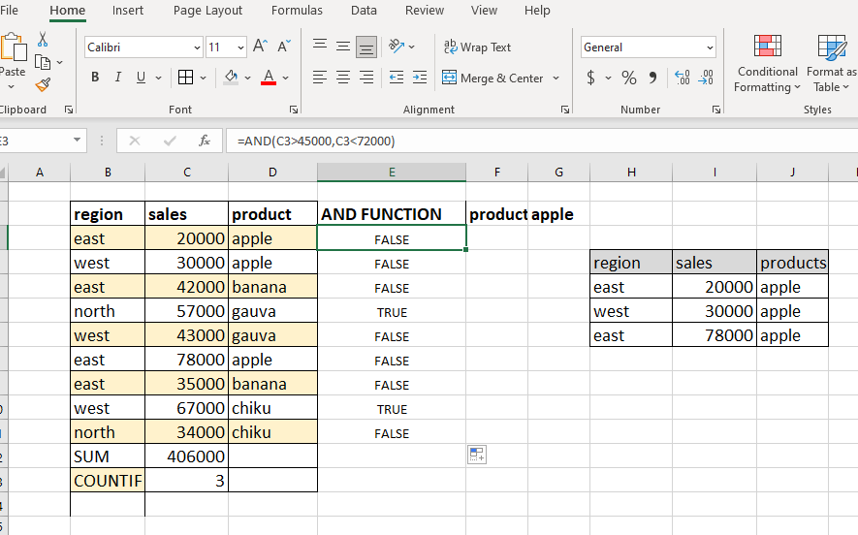

**Filter function:**

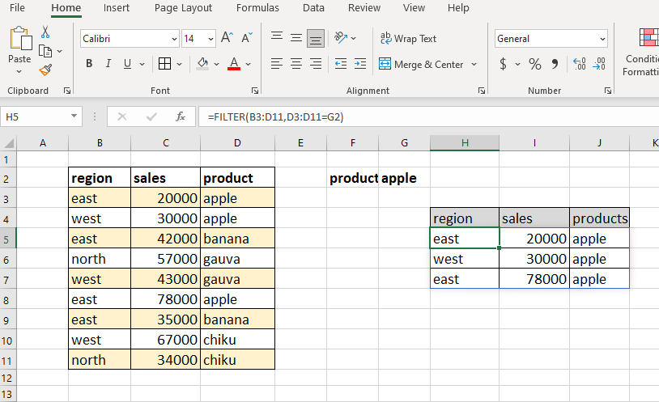

**Eomonth function:**

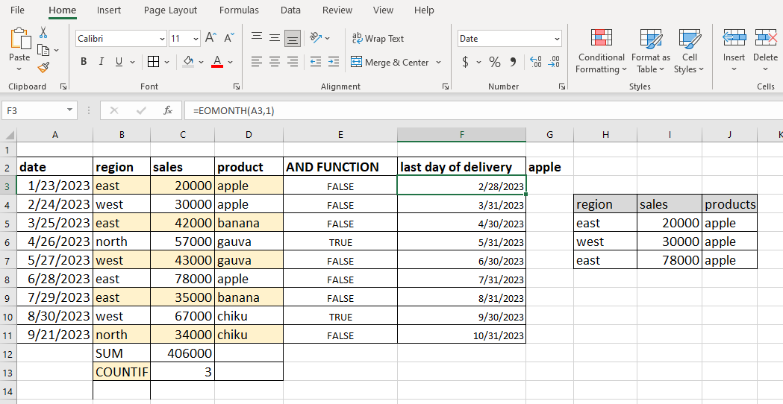

|  |  |
| --- | --- |
| **EXAMPLE** | **DESCRIPTION** |
| =SUM (C3:C11) | adds the values in cell C3:C11. |
| =COUNTIF(C3:C11,">45000") | Counts the number of cells with a value greater than 45000 in cell C3 to C11. |
| =AND(C3>45000, C3<72000) | If C3 is greater than 45000 and C3 <75000 then returns true or else false |
| = FIND (“a”,” swarda dixit”,4) | Position of the first “a” in string, starting with third character |
| =FILTER (B3:D11, D3:D11=G2) | Returns the products name as apple |
| =EOMONTH(A3,1) | Date of the last day of month, one month after the day in A3 |

**2.** **What are the different ways you can select columns and rows?**

* Click on any cell and press Ctrl + Shift +right arrow and then down arrow
* Click and drag
* Click on any cell in the column and then press Ctrl + Space

**3. What is AutoFit and why do we use it?**

It automatically resize cells in a worksheet to accommodate different sized data without having to manually change the column width and row height. By using autofit we can easily resize the cell so that we can see the data easily in organized manner.

**4. How can you insert new rows and columns into the existing table?**

Right click on the cell above which you want the new row and click on insert.

Same for the column, right click on the column before which you want the new column to be added and click on insert.

**5. How do you hide and unhide columns in excel?**

* Select the column that you want to hide.
* Right click on selected column and select hide.
* For unhiding right click between the line where the column is hidden then right click and select unhide.

**6. Create an appropriate table within the worksheet and use different functions available in the AutoSum command.**

